Ready Reference  Management Centre Quick Start | RR6
Practice with the BCH Training Site

Use your existing BCH account to practice registering record on the BCH Training site.

Web address:

https://bch.cbd.int/resources/trainingsite.shtml

Access the Management Centre

Web address:

https://bch.cbd.int/managementcentre/

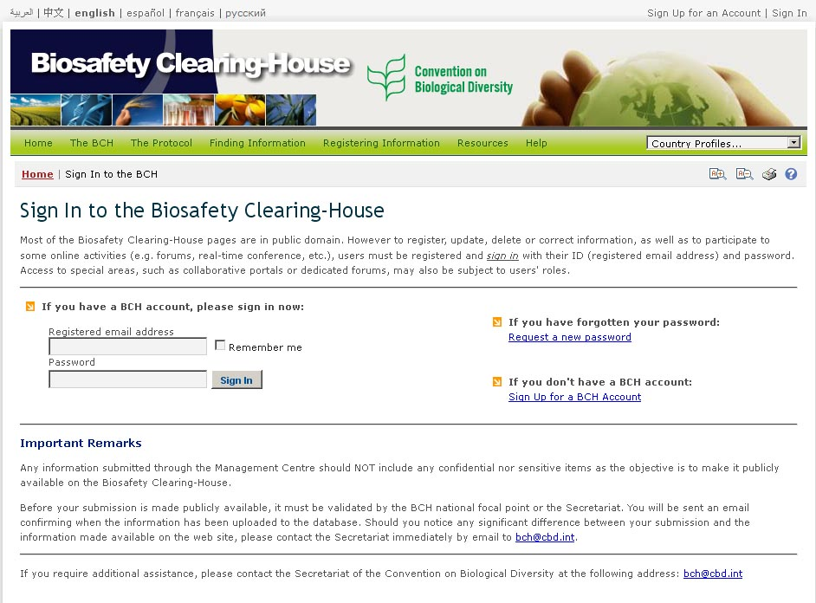
1
3
2
4
 | Open the Management Centre | Open the Management by following the link Registering information.
 | Forgotten password | Re-set your password by following the instructions on the Management Centre home page.
 | Get a BCH account | Sign-up for a BCH account by filling in the online form.
 | Sign-in to your account | Enter your email address and password and click the “sign-in” button.

Navigating the Management Centre Home Page

Web address:

https://bch.cbd.int/managementcentre/

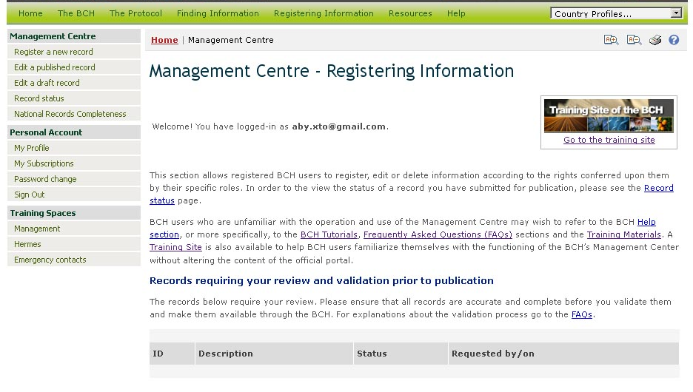
4

 | Register a new record | Use this link to submit new information
 | Edit a published record | Use this link to manage information you have previously submitted
 | Edit a draft records | Use this link to access your draft records.
 | Training site | Link to the training site of the BCH
1
2
3

Creating new records
1
2
3

Web address:

https://bch.cbd.int/managementcentre/register/

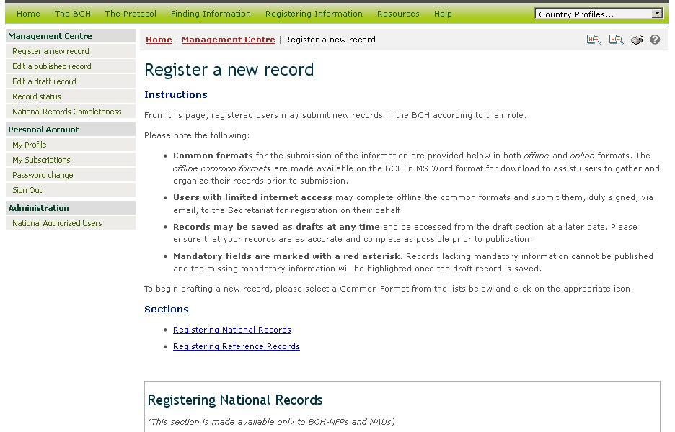
1

 | Record type | Choose a record type: National records or Reference records
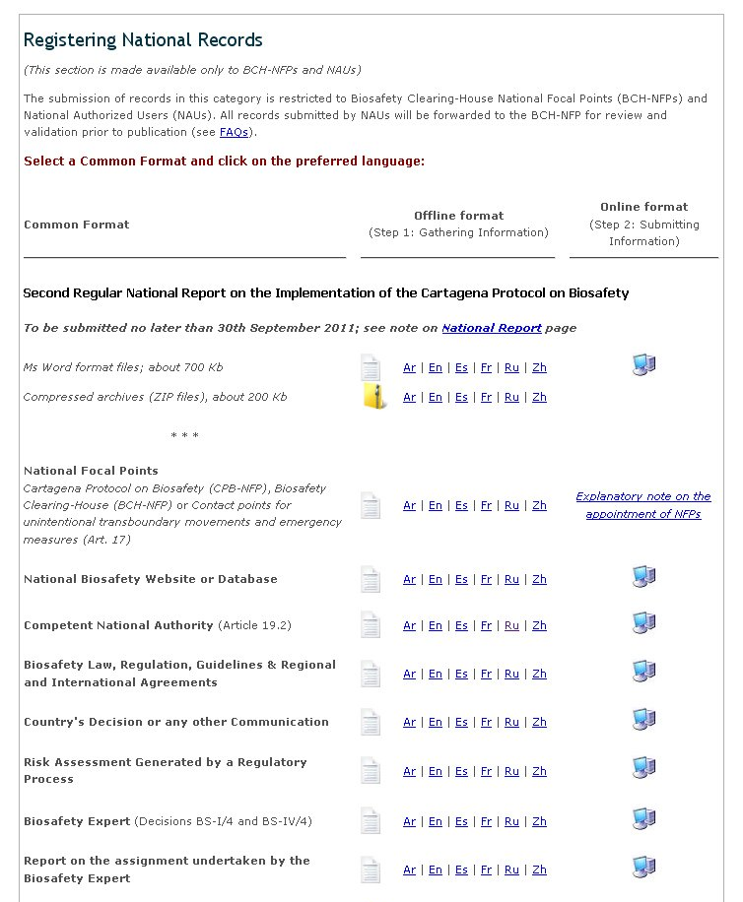
2
3
4

 | Category of a new record | Select record category (common format) from the list
 | Offline format | Download a copy of the common format in necessary language for selecting and preparing information for registering or entering information off-line.
 | Online format | Use the link (the icon ) appropriate to the necessary record category for registering information in the BCH.

Edit existing records
1
2
3
4

Web address:

https://bch.cbd.int/managementcentre/edit.shtml

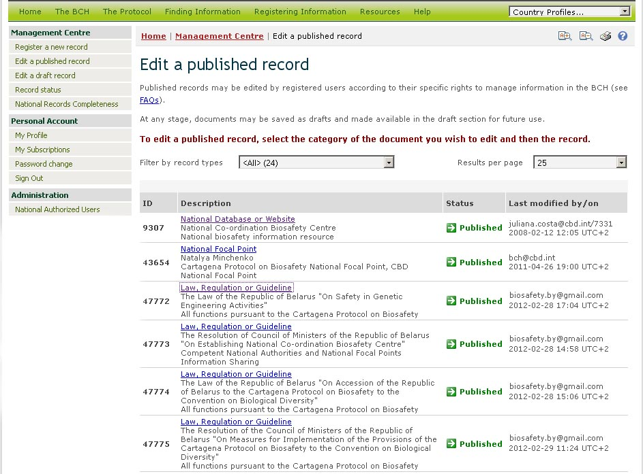
1

1 | Record | Use the link in the list of descriptions to choose a published record for editing.

Edit draft records
4

Web address:

https://bch.cbd.int/managementcentre/draftedit.shtml

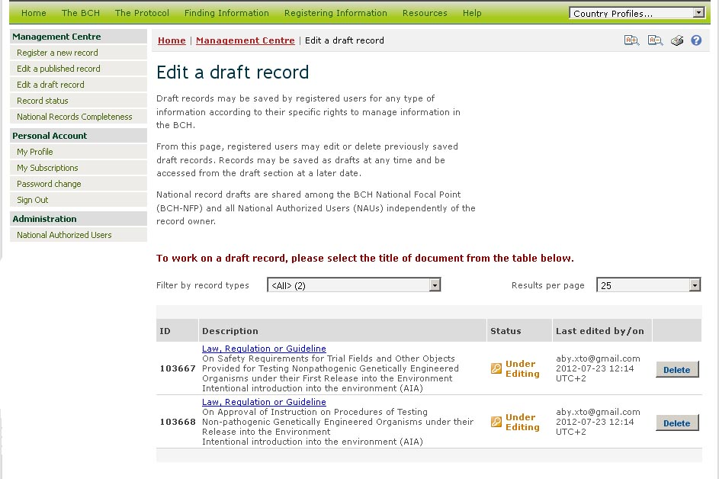
1
2

1 | Record | Choose a draft record for editing by the link in the list of their descriptions or
2 | Delete draft record | Delete unnecessary draft record by clicking on the button “Delete”

